|  |
| --- |
| 新东方在线英语学习 |
| 新概念 1 册 |
| Lesson107-108 |



扫一扫。更多有趣的英语资讯。

# Lesson 107 单词讲解

1. madam: n.夫人，女士(对妇女的尊称) mai dai me
2. lady
3. as well : 同样也~ also\ too

also: 肯定句，实义前情系后，比较正式

too: 肯定句疑问句句末，比较口语

as well: 不用于否定句，句末这个商店也卖婴儿食品。

The shop sells food for babies as well. The shop sells food for babies too.

The shop also sells food for babies. 3.suit: v.适于

It suits you well. It doesn’t suit me.

suitable adj. 适宜的，合适的

4.pretty: adj.漂亮的prui di

# Lesson 107 课文讲解

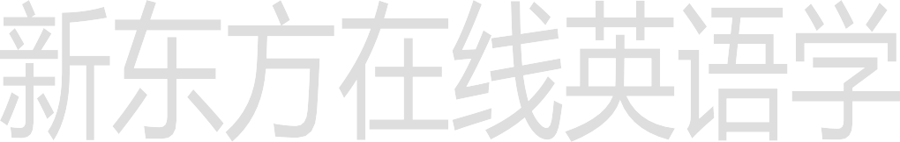

1. It’s too small.

too

1. It’s too small for me. for me, 对于我来说

Math is too difficult for him.

数学对他来说太难了。

1. Short skirts are in fashion now. in fashion= fashionable out of fashion

Tight jeans were in fashion last year.

去年流行紧身牛仔裤。

1. Would you like to try…?

would like to + v. … 想要做… would like + sth. … 想要…

I would like a new pair of shoes.

I would like to buy a new pair of shoes. want + n. 想要…

want to + v.想要做…

疑问句时表达委婉的请求

* + Would you like to go to my party?

你可以来参加我的晚会？

* + Yes, I’d love to.
  + Would you like some tea or coffee?

您是要点茶还是咖啡？

- I’d like tea please.

1. I’m afraid this green dress is…for me as well. as well, 也

…this green dress is…for me too.

…this green dress is also too small for me.

1. I don’t like the color either. either, 否定句末

他也不喜欢咖啡。

He doesn’t like coffee either.

1. I think the blue dress is prettier. pretty- prettier- the prettiest
2. Could you show me another blue dress? Could you+ v….? 你 … 可 以 吗 ？ Could you lend me some money? Could you give me a hand?
3. It must be my size. be?

情态动词+动词原形

It is my size.



10. I haven’t got a larger dress.

This is the largest dress in the shop. large- larger- the largest

**Lesson 107 语法讲解**

比较级& 最高级

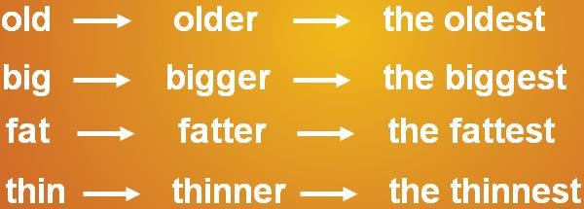

比较级\ 最高级变化规则

1. 以 e 结尾, 直接加 r, st; late- later- the latest
2. 辅+元+辅 (汉堡堡结构)，

双写最后一个辅音字母加er, est; fat - fatter- the fattest

1. 辅音字母加y 结尾,变 y 为 i,加 er, est happy- happier- the happiest

比较级的句型结构：

主语+谓语（系）+比较级 +than…

他比以前帅。

He is cooler than before.

她比从前时尚。

She is smarter than before.

他比其他人都快。

He was faster than any other one.

最高级的句型结构：

主语+谓语（系）+ the+ 最高级+ 范围他比其他人都快。

He was faster than any other one.

这是全世界最大的一只兔子。

It is the biggest rabbit in the world.

他是全世界最矮的人。

He is the shortest man in the world.

今天是这个月最忙的一天。

It is the busiest day in this month.

他是我们当中个子最高的。

He is the tallest of us all.



**Lesson 108 单词句型讲解**

Hans is the tallest student in our class.

The day before yesterday was the hottest day in a year.

It is the largest crowd I have ever seen. I have ever seen. 我所见过的

2.stupid: adj.笨的

缺乏理智,先天迟钝、智力低下

silly:

缺乏常识、判断力,作出令人可笑的行为和举止

3.cheap: adj.便宜的4.expensive: adj.贵的5.fresh: adj.新鲜的6.stale: adj.变馊的7.low: adj.低的，矮的8.loud: adj.大声的9.high: adj.高的

# Lesson 107&108 知识拓展

比较级&最高级的有用句型：

1. East, west, home is best.

金窝银窝，不如自己的草窝。

1. Facts speak louder than words.

事实胜于雄辩。

1. Health is better than wealth.

健康高于财富。

1. It is better to be the head of dog.

宁为鸡头不做凤尾。

1. The sauce is better than the fish.

喧宾夺主*。*

1. 没有最好只有更好。

There is no best, but better. To make the best even better.

